

*Department of Software Engineering*

***Bahria University Karachi Campus***

**Course Title: Database Management System**

**Course code:** **CSL 220**

**Course instructor:** **Engr Laraib Siddique**

**Lab instructor:** **Engr Ayesha Khan**

**<Car Dealership System>**

**BSE. (4-(B))**

**DBMS SEMESTER PROJECT REPORT**

**by**

**<Syed FAwad Ali Jaffery> <02-131202-058>**

**<Hassan Khan> <02-131202-069>**

**<Hamza bin atiq> <02-131202-070>**

**Table of Contents**

1. **Acknowledgement**
2. **Abstract**
3. **Introduction**
4. **Project Scope**
5. **Project Modules**
6. **Diagrams**

* **Usecase Actor Diagram**
* **ER Diagram**
* **DB Diagram**

1. **Table Names**
2. **Technologies**
3. **Project Screenshots**

**acknowledgement**

in this project we have implemented the datbase management system taught throughtout the semester by our course instructor miss laraib siddiqui and lab instructor miss ayesha khan.

**Abstract**

Car dealership system allows seller and buyer to meet at one place,

Displayed ads can be seen by buyers and admin, buyers can book the car they like which will be deleted from ads, once they booked it, so that one car won’t be booked twice. For buying or selling the customer needs to be registered with its identity to keep a record of its behavior.

**introduction**

Our project is about car selling and purchase through site, buyers can visit site and book car they like. Sellers can post ads to sell. It gives customer facility to buy and sell through application. Admin has rights to look after the records of cars and the change in it.

**project scope**

The application will be used by car sellers and buyers. Sellers post ads to sell cars. Buyers order the cars from given ads. Admin can administer the functionality performed on ads.

**project MODULES**

**ceate account by seller**

**ceate account by buyer**

**Login for buyer**

**Login for Seller**

**Login for admin**

**post ads**

**display ads**

**Manage ads**

**car booking**

**diagrams**

* **usecase actor**

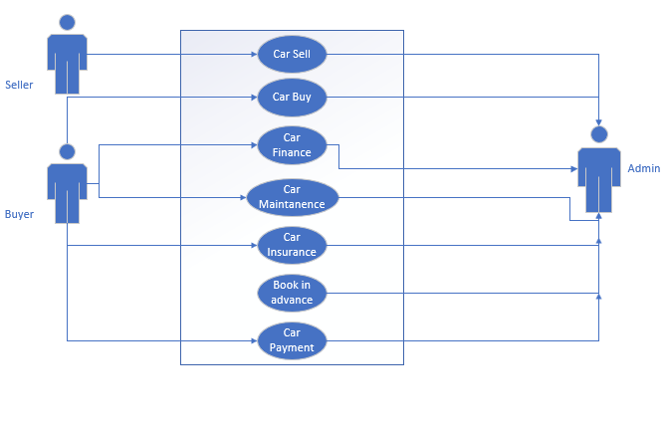

* **er diagram**

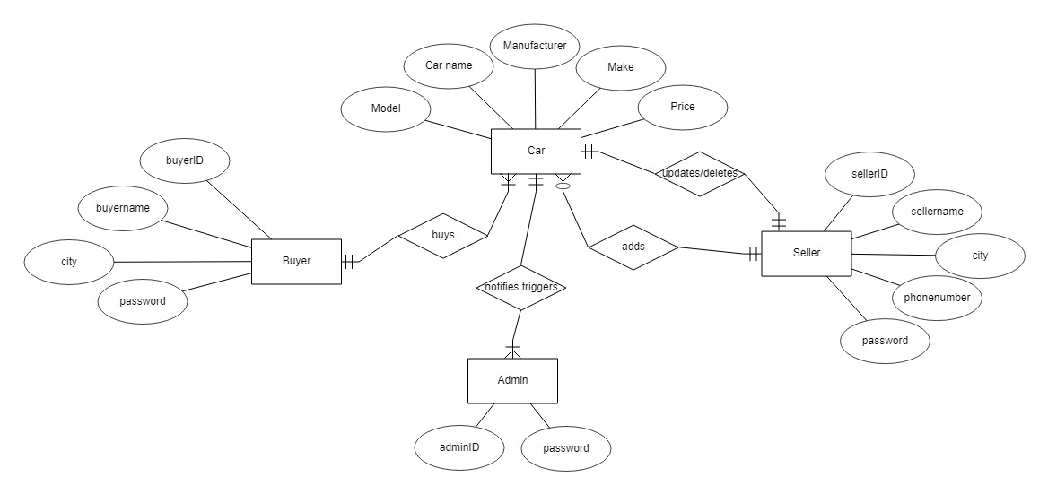

* **db diagram**

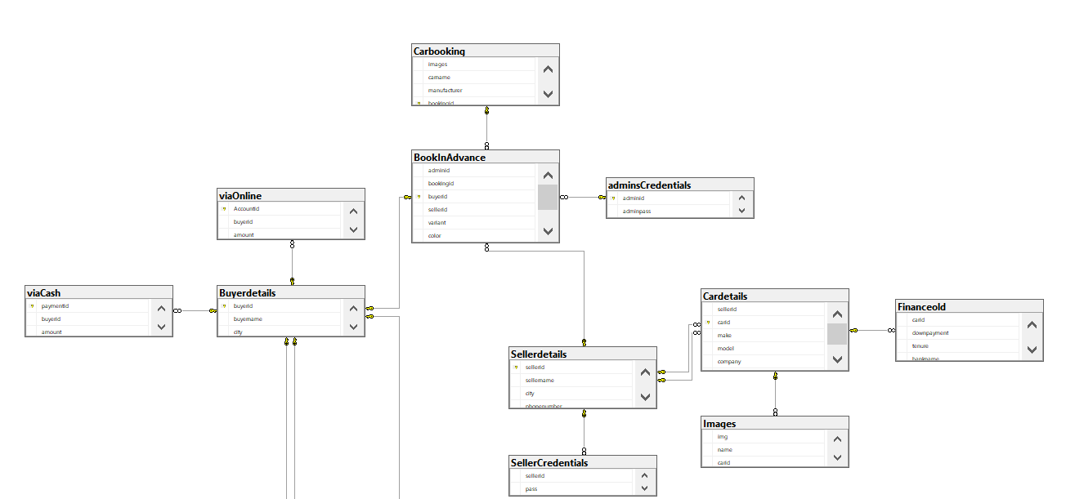

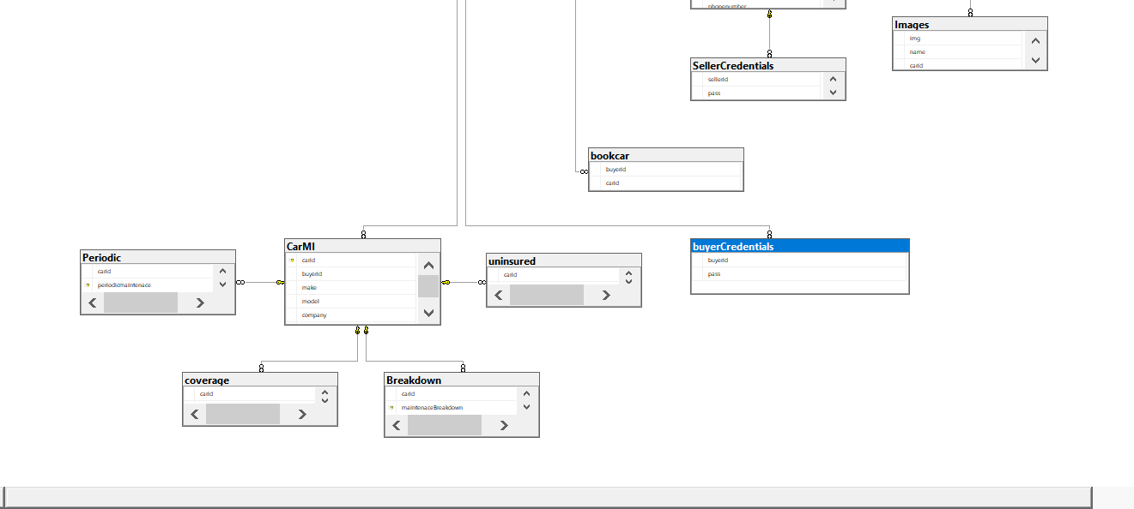

**TABLE NAMES**

**Images**

**Cardetails**

**Sellerdetails**

**Buyerdetails**

**viaOnline**

**viaCash**

**Financeold**

**CarMI**

**Breakdown**

**Periodic**

**Uninsured**

**Coverage**

**Carbooking**

**BookInAdvance**

**SellerCredentials**

**buyerCredentials**

**admisCredentials**

**bookCar**

**TECHNOLOGIES**

**MS SQL Server**

**ASP .Net Webfor**

**PROJECT SCREENSHOTS**

**Home:**

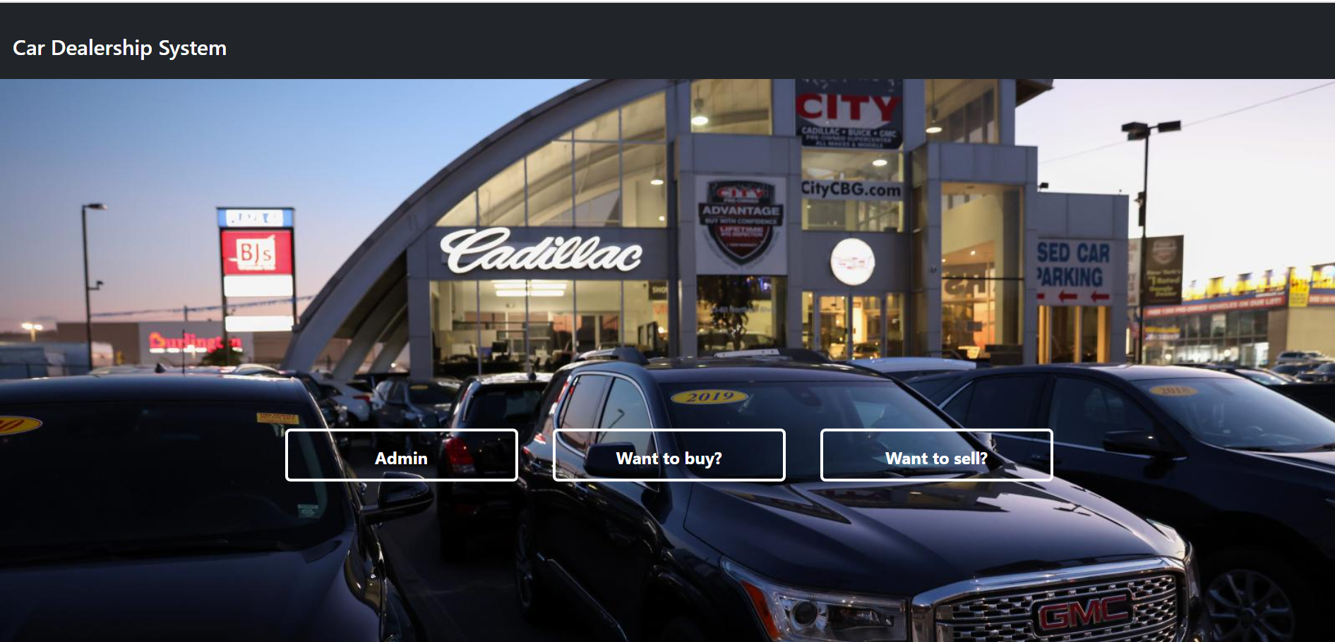

**Seller:**

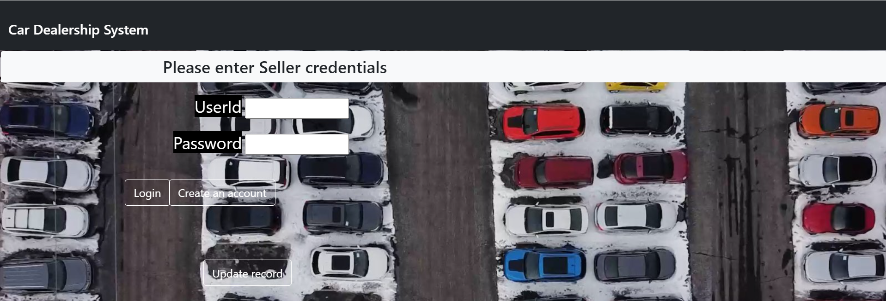

**For creating account:**

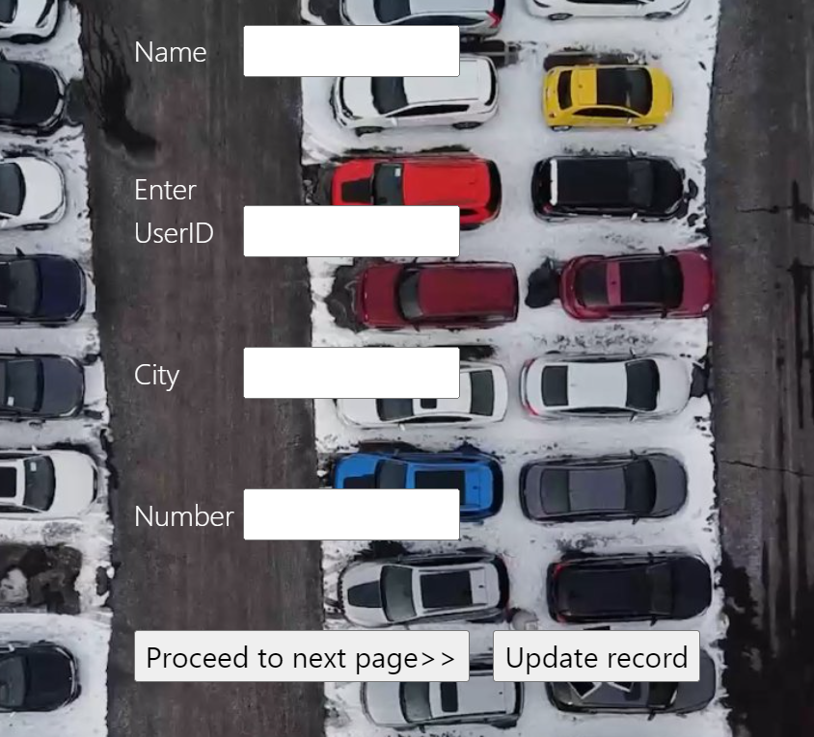

**To add record:**

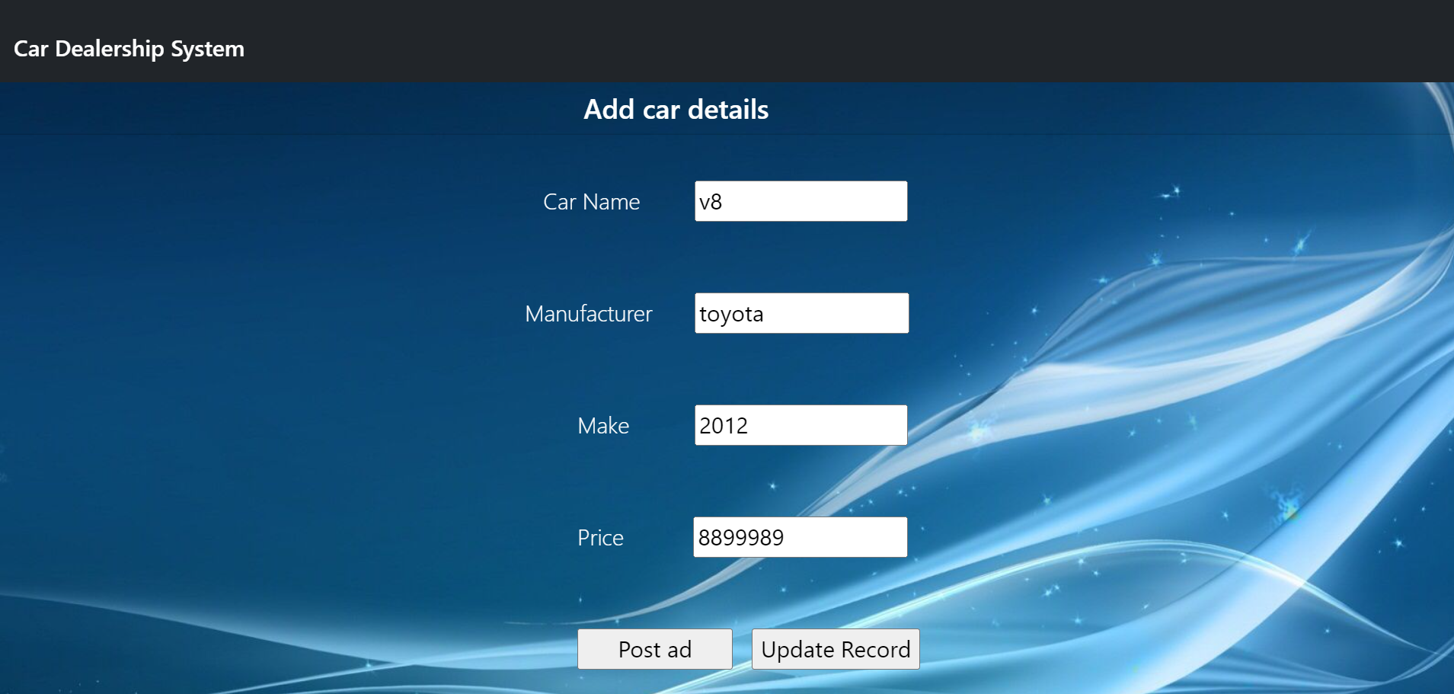

**Display ads:**

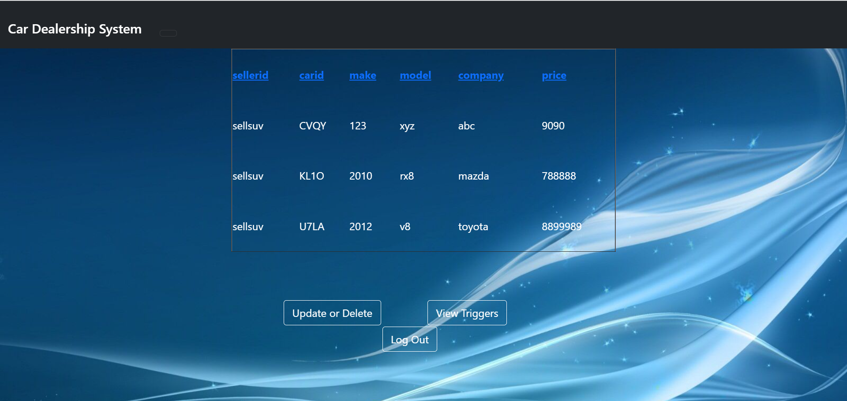

**To update/delete records:**

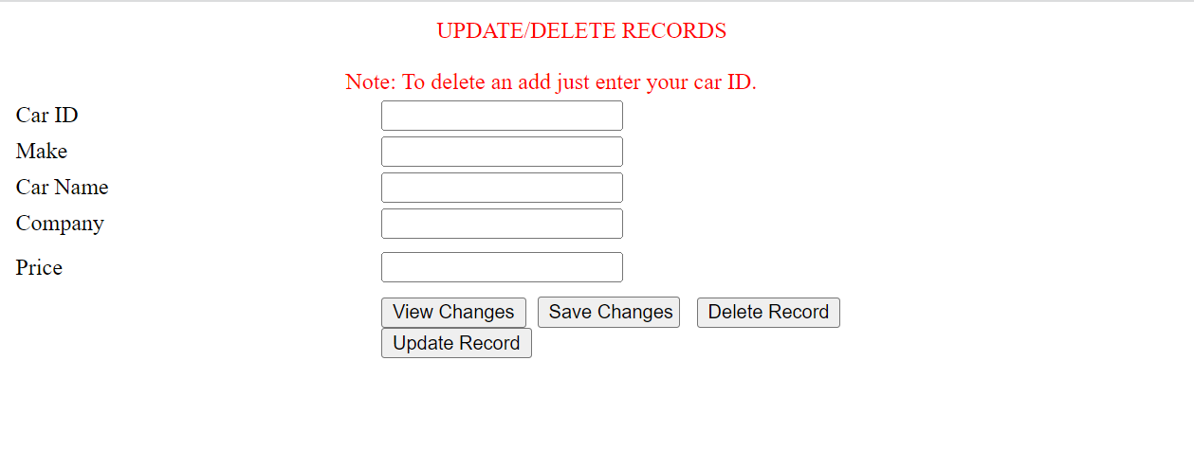

**Display ads:**

